

The goal of this course is to get systems work fast and efficiently.

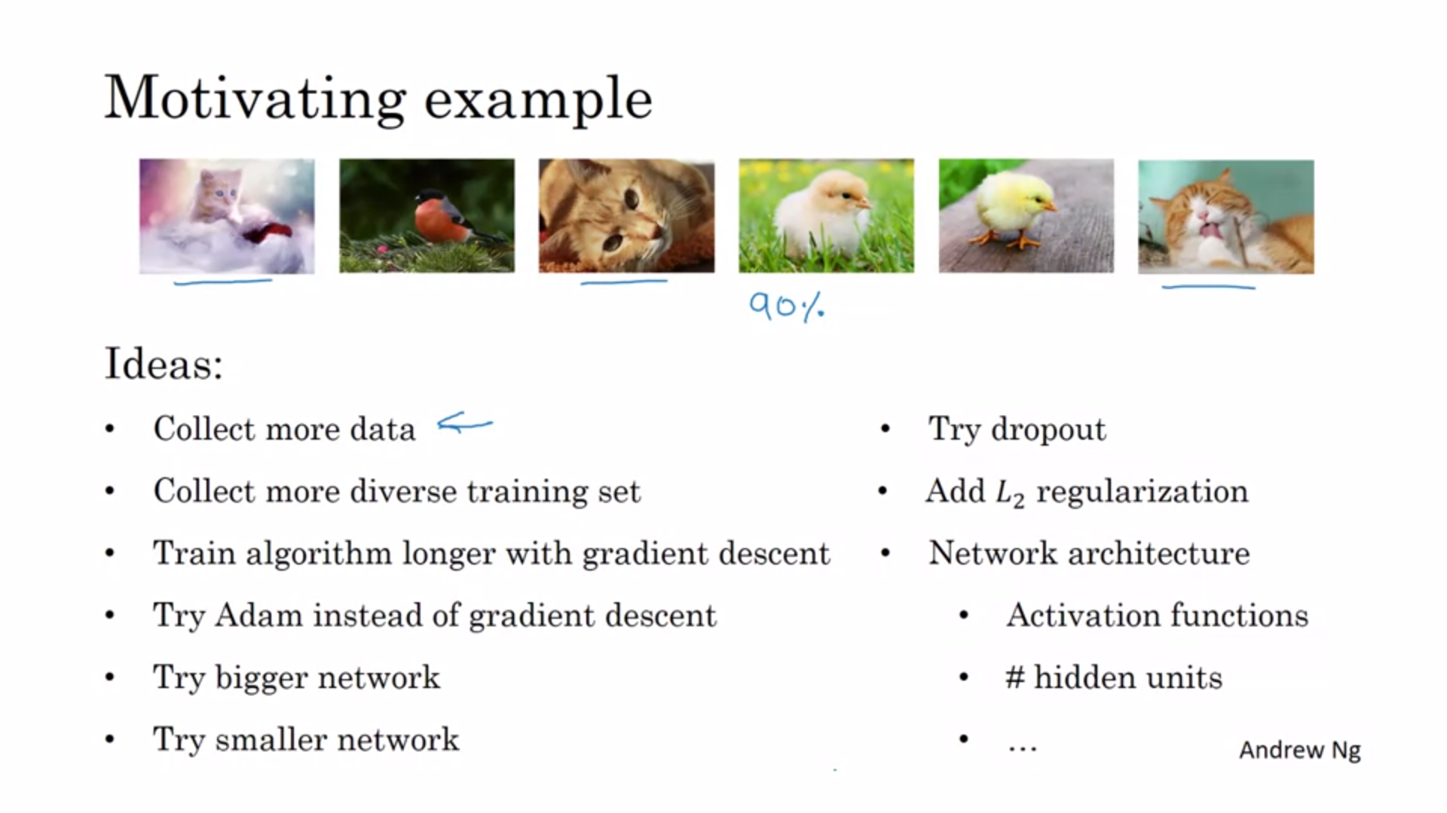

Let’s assume you have 90% accuracy but that is not good enough. Normally there are a lot of ideas what you can try. Choosing poorly might cost a lot of time.

We need quick and effective ways to figure out which ideas are worth pursuing.

Andrew will share some lessons that he learned while producing and shipping lots of deep learning products.



One of the challenges with ML is that there are so many things to try and change. Good ML practitioners know what to tune to get what effect -> orthogonalization.

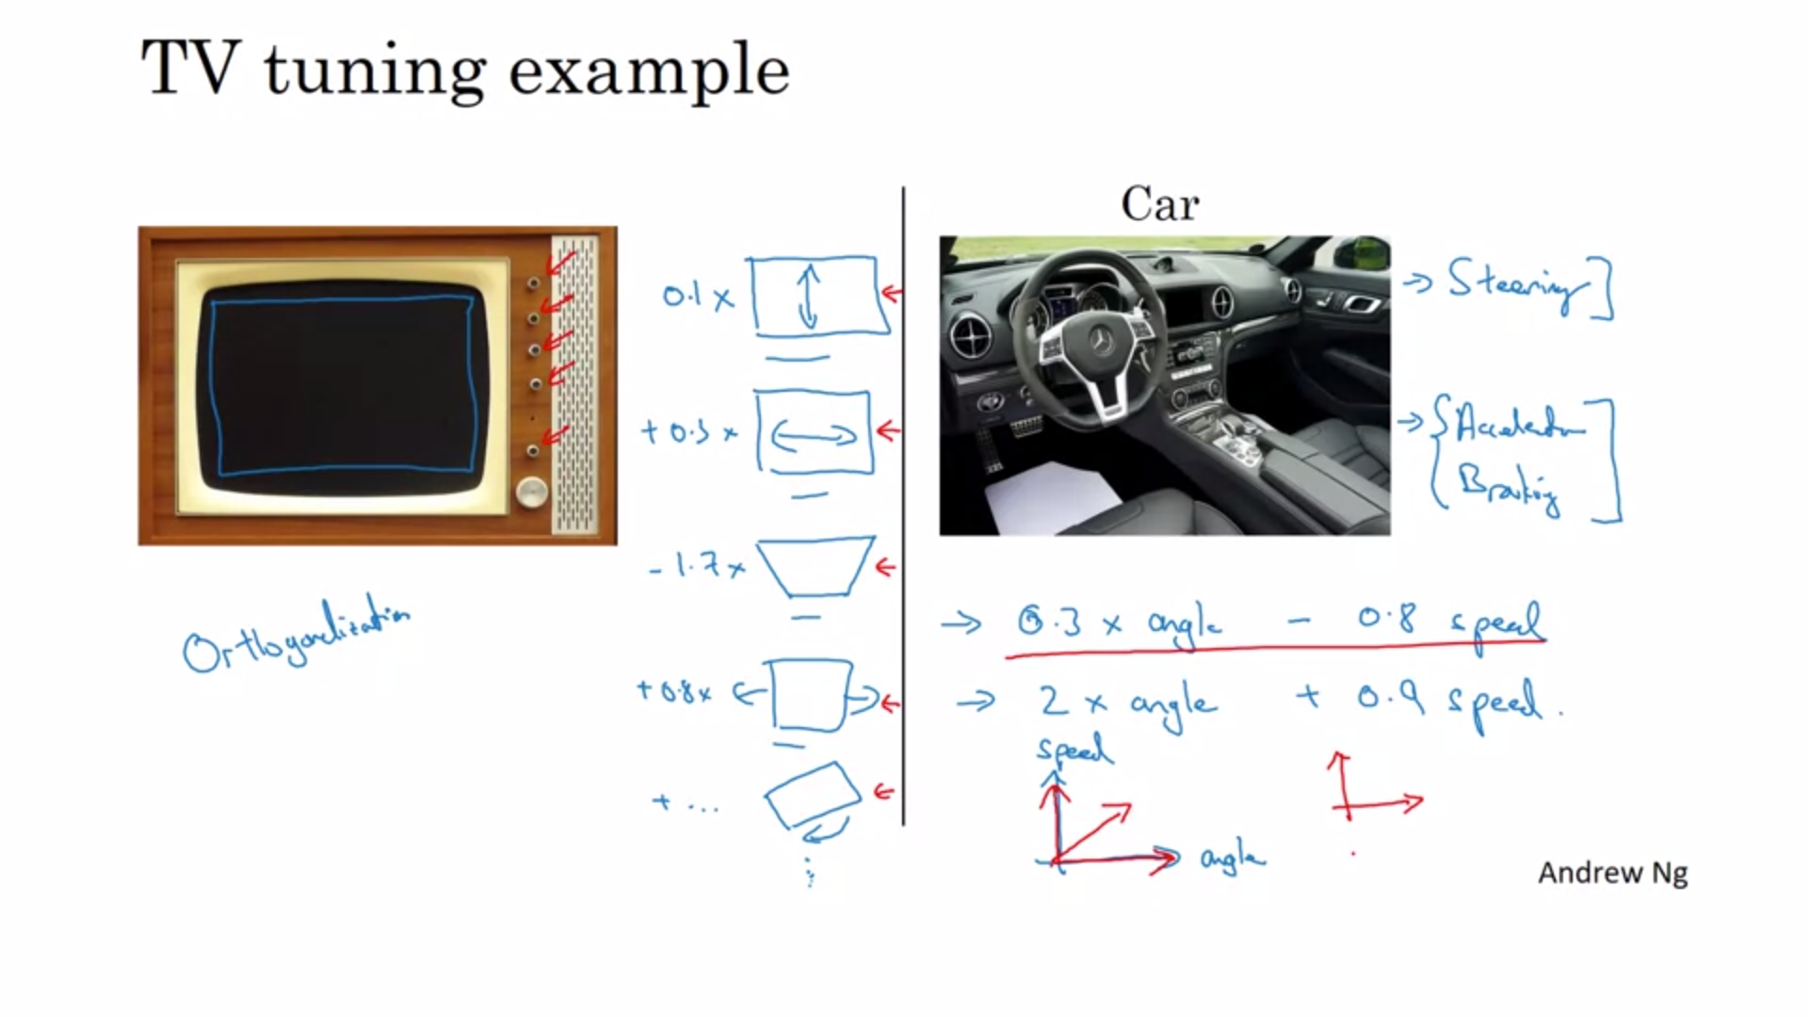

It would not be very useful if everything changes a bit once a nob is turned. Orthogonalization here means that the TV designer have designed the TV so that every nob only does one specific thing.

In theory you can get your desired state but it is much harder.

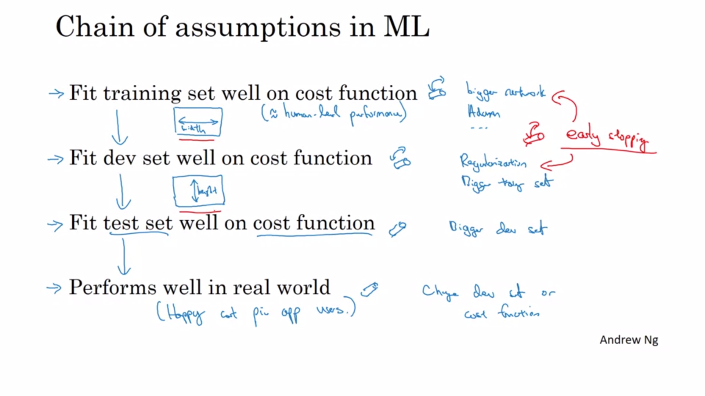

How does this relate to ML? We want to tune the nobs to get the above results. We want one nob to only affect one thing.

Andrew tends not to use early stopping (a lot of people do it though) because it is less orthogonalized.